INSERT PAPER TITLE (USE “JEASD TITLE” STYLE)
Author’s Name^{1*}, Author’s Name², Author’s Name³
(First Name Surname order, use “Authors Name” style, use star “*” to indicate the corresponding author)
¹First author’s affiliation (Use “Authors Affiliation” style, (https://orcid.org/0000-0001-0000-0000))
²Second author’s affiliation (Use “Authors Affiliation” style(https://orcid.org/0000-0001-0000-0000))
³Third author’s affiliation (Use “Authors Affiliation” style(https://orcid.org/0000-0001-0000-0000))

Received 00/00/0000 | Accepted in revised form 00/00/0000 | Published 00/00/0000

Abstract: The abstract should be between 150-250 words. It should briefly indicate the general scope and also state the main results obtained, methods used, the value of the work and the conclusions drawn. No figure numbers, table numbers, references or displayed mathematical expressions should be included. Emphasis should be on what was found more than what was done. Use the “Abstract” style. Do not use abbreviations in the abstract.
Keywords: 4 to 8 words; be separated by Semi-colon “;”. Do not use abbreviations.

1. Introduction - First Level Heading (Capitalize Each Word, use “Heading 1” style).
Use the “JEASD Paragraph” style. The introduction should set the paper’s tone by providing a clear statement of the study, the relevant literature on the subject, and the proposed approach or solution. The introduction should be general enough to attract a reader’s attention from a broad range of scientific disciplines. This template, created in MS Word 2010, provides authors with most of the formatting specifications needed for preparing their papers. Margins, line spacing, and type styles are built-in; examples of the type styles are provided throughout this document.
The bullets should be used as:
- Bullet one (Use “Paragraph - bullets)” style).
- Bullet two (Use “Paragraph - bullets” style).

Numbers/List should be as follows:
- Number 1 (Use “Paragraph - numbers” style)
- Number 2 (Use “Paragraph - numbers” style)

2. Custom Title - First Level Heading (Capitalize Each Word, use “Heading 1” Style).

2.1. General - Second Level Heading (Capitalize Each Word, use “Heading 2” style).
First, confirm that you have the correct template for your paper size. This template has been tailored for output on the A4 paper size. Do not bother about the header or footer or content of the article just paste your content in the template, replacing the content. Please fit your article in this template exactly following the author’s guidelines without any deviation.

2.2. Margins and Line Spaces - Second Level Heading (Capitalize Each Word, use “Heading 2” style).
The template is used to format your paper and style the text. All margins, line spaces, and text fonts are prescribed; please do not alter them.

2.2.1. Comments - Third Level Heading (Sentence case, use “Heading 3” Style).
Before you begin to format your paper, first write and save the content as a separate text file. Keep your text, and graphic files separate until after the text has been formatted and styled. Do not add any kind of pagination anywhere in the paper. Do not number text heads, the template will do that for you.

2.2.2. Abbreviations - Third Level Heading (Sentence case, use “Heading 3” Style).
Abbreviations should be defined at first mention in the abstract and again in the main body of the text and used consistently thereafter. Do not use abbreviations in the title or heads unless they are unavoidable. A list of symbols should be inserted before the references if such a list is needed. Symbols must be written clearly. The international system of units (SI units) should be used in the text, tables and figures. Symbols for physical quantities in the text should be written in Italics (e.g., v, T, etc.). Symbols for units containing letters should be in plain text (e.g., Pa, m, etc.).

2.2.3. Equations - Third Level Heading (Sentence case, use “Heading 3” Style).
When writing mathematics, avoid confusion between characters that could be mistaken for one another, e.g., the letter ‘l’ and the figure one. Refer to equations using round brackets, e.g. (1). Use MS equation editor. Avoid using “picture” for equations.
$X+Y=Z$ (1)
$X_{1}+Y^{2}=B$ (2)
Note that the equation is centered using a center tab stop. Be sure that the symbols in your equation have been defined before or immediately following the equation. Use “(1)”, not “Eq. (1)” or “equation (1)”, except at the beginning of a sentence. For example, “Equation (1) is used to describe …etc.”

3. Figures and Tables - First Level Heading (Capitalize Each Word, use “Heading 1” Style).

3.1. Figures - Second Level Heading (Capitalize Each Word, use “Heading 2” style).
Figure captions should be below the figures. Insert figures and tables after they are cited in the text. Use the abbreviation “Fig. 1”, even at the beginning of a sentence. When placing more than two figures and photos under the same number of titles, assign subtitles by dividing each figure and photo by (a) or (b). The font style and size used in
The figures should be equal or less than the font used in writing the manuscript (i.e. Times New Roman ≤ 12). Do not use a shadow or frame around the figure. Multi-curve graphs should have individual curves marked with a symbol; the symbol’s meaning should be explained in the figure caption. Good quality black-and-white photographs or scanned images should be supplied for the illustrations. Provide high-resolution figures.
Use “Section Breaks – Continuous” if necessary to expand a figure into one column.
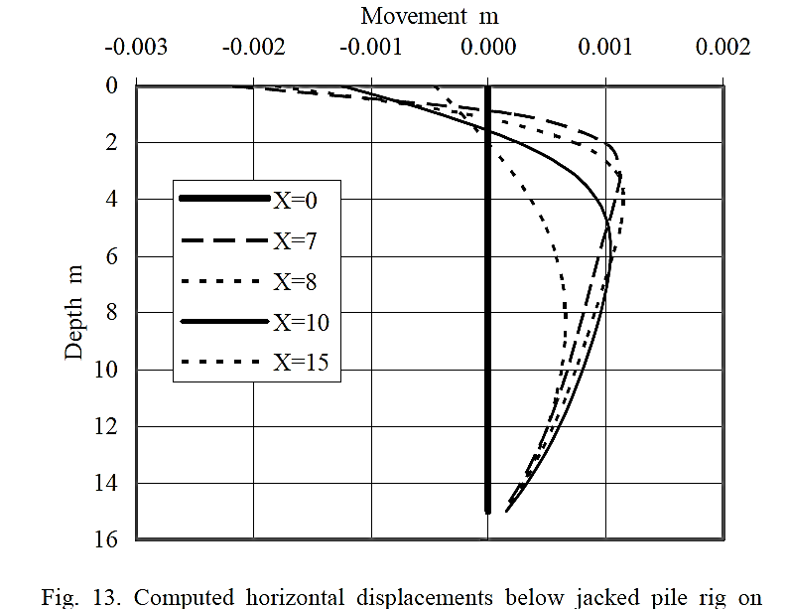
Figure 1. Black and white figure without shading or frame (Use “Figures caption” style) (Sentence case)

Figures should be inserted after their first mention. After inserting a figure in the manuscript, do the following steps:
- Select the figure.
- Click the “Layout Options button,” which is found lingering near the image’s upper right corner.
- Choose “In line with Text.”

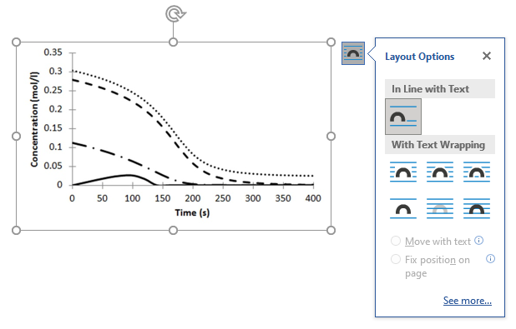
Figure 2. Figure layout.

3.2. Tables - Second Level Heading (Capitalize Each Word, use “Heading 2” Style).
Insert tables after they are cited in the text. Tables are referred to in the text by “Table X.” (capital T). Table heads should appear above the tables. Avoid any colors or shadings in the table.
Use “Section Breaks – Continuous” if necessary to expand the tables into one column.
Use “Tables caption” style for table caption and “Table body” style for text inside the table. The first raw should be bold. Do not use shading in the tables.
Remove the inside borders from the table. Borders are only above and below the first raw and below the last raw.
Tables must be in editable format. Avoid using pictures.
Table 1. Insert table caption here. (Use “Table caption” style, Sentence case)
Column 1 | Column 2 | Column 3 | Column 4
Row 1 | Row 1 | Row 1* | Row 1
Row 2 | Row 2 | Row 2 | Row 2
Row 3 | Row 3 | Row 3 | Row 3
Row 4 | Row 4 | Row 4 | Row 4
Row 5 | Row 5 | Row 5 | Row 5
Row 6 | Row 6 | Row 6 | Row 6
Any footnotes should be indicated by the use of a superscript “*”

Go to the properties of the table. Seclect “centered” alignment and “None” from text wrapping.

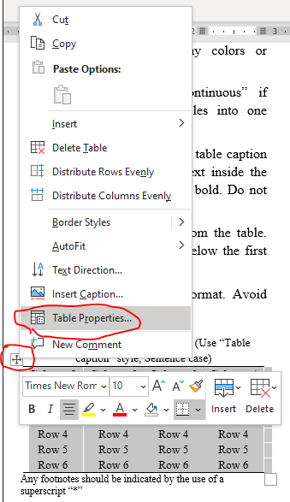
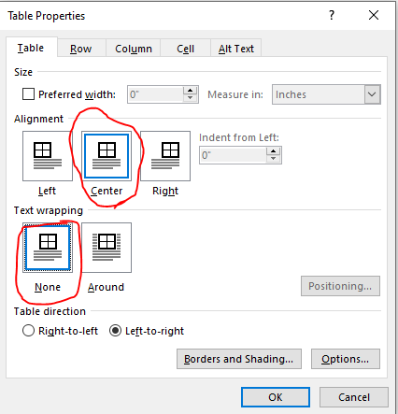
Figure 3. Table properties.

4. Conclusions - First Level Heading (Capitalize Each Word, use “Heading 1” style).
A conclusion should point out the distinguished results of the achieved work and do not replicate the abstract. A conclusion may suggest recommendations for work extension and new applications.

Acknowledgements - First Level Heading (Capitalize Each Word, use “Heading 1” Style).
The author(s) may express his/her appreciation to relevant agencies and related personnel providing financial support or academic advice to his or her research.

Abbreviations - First Level Heading (Capitalize Each Word, use “Heading 1” Style).
A list of symbols should be inserted before the references if such a list is needed. Sort in alphabetical order.
A | Coefficient matrix
E | Modulus of elasticity
R_{f} | Failure ratio
t | Time
γ | Unit weight of material
ѵ | Poisson’s ratio
φ | Friction angle
εv | Volumetric strain

Conflict of interest - First Level Heading (Capitalize Each Word, use “Heading 1” style).
The author(s) should mention that the publication of this article causes no conflict of interest. A conflict-of-interest statement must be placed in the manuscript as below: “The authors declare that there are no conflicts of interest regarding the publication of this manuscript”.

Author Contribution Statement
The Author Contributions section should specify the exact contributions of each author in a narrative form. For instance:
Authors A.B. and C.D: proposed the research problem.
Author A.B.: developed the theory and performed the computations.
Author C.D.: verified the analytical methods and investigated [a specific aspect] and supervised the findings of this work.
Both authors discussed the results and contributed to the final manuscript.

References - First Level Heading (Capitalize Each Word, use “Heading 1” style).
Ensure that every reference cited in the text is also present in the reference list (and vice versa). References should be cited by numbers in square brackets in the forms: [1], [1, 2], [1-6]. They should be listed and numbered in their citation order in the text, not by name and date.
Refer simply to the reference number, as in [3], do not use “Ref. [3]” or “reference [3]”. The actual authors can be referred to, but the reference number(s) must always be given. Example: “.... as demonstrated in [1,2]. Brandl and Blovsky [4] obtained a different result ...”. This effect has been widely studied [1-3, 7]
Use the “References” style for writing references.
Unless there are three authors or more, give all authors’ names; do not use “et al.”. The list of references should include only works that are cited in the text and that have been published or accepted for publication. Please follow the reference method exactly as per journal guidelines.
Examples of the ways in which references should be cited are given below.
Journal
- Al-Moameri, H.H., Hassan, G., and Abdulrehman, M.A., (2020). Predicting The Composition Of Qurna Crude Oil Fraction By Ternary Composition Diagram. Methods and Objects of Chemical Analysis. Vol. 15, Issue 1, pp. 33–39. https://doi.org/10.17721/moca.2020.33-39.
- Kolodziej, P., Macosko, C.W., and Ranz, W.E., (1982). The influence of impingement mixing on striation thickness distribution and properties in fast polyurethane polymerization. Polymer Engineering & Science. Vol. 22, Issue 6, pp. 388-392. https://doi.org/10.1002/pen.760220611.

Conference Paper
- Al-Moameri, H.H., Hassan, G.S., and Jaber, B.N.(2019). Simulation Physical and Chemical Blowing Agents for Polyurethane Foam Production. in IOP Conference Series: Materials Science and Engineering - 2nd International Conference on Sustainable Engineering Techniques, ICSET 2019. Baghdad, Iraq: Institute of Physics Publishing. https://doi.org/10.1088/1757-899X/518/6/062001.

Book
- Ashida, K., (2006). Polyurethane and Related Foams: Chemistry and Technology. 1st ed. 2006, New York: CRC Press. 154B. ISBN: 9780203505991.

Book Section
- Schnohr, C.S. and Ridgway, M.C., (2015). Introduction to X-Ray Absorption Spectroscopy, in X-Ray Absorption Spectroscopy of Semiconductors, C.S. Schnohr and M.C. Ridgway, Editors, Springer Berlin Heidelberg: Berlin, Heidelberg. p. 1-26. https://doi.org/10.1007/978-3-662-44362-0_1.

Thesis/Dissertation
- Faris, G.H. (2017). Advanced Simulation of Thermoset Reaction and Catalyst Performance. Thesis, Chemical Engineering Department, Mustansiriyah University, Baghdad, Iraq. https://doi.org/XX.100/5689-333-123456.

Standard
- ASTM D4533-91. (1996). Standard Test Method for Trapezoid Tearing Strength of Geotextiles. International, A., West Conshohoken, PA, USA.

Web page
- Mehra, A. (2020). Polyurethane Foam Market worth $61.5 billion. [cited 2022; 1st:[Available from: http://www.marketsandmarkets.com/PressReleases/polyurethane-foams.asp.

Appendix – A
If there is a need for some derivations or equations which is important to support the research, they should be inserted after the references. The equations are numbered according to the type of appendix. For example
$X+Y=Z$ (A-1)

