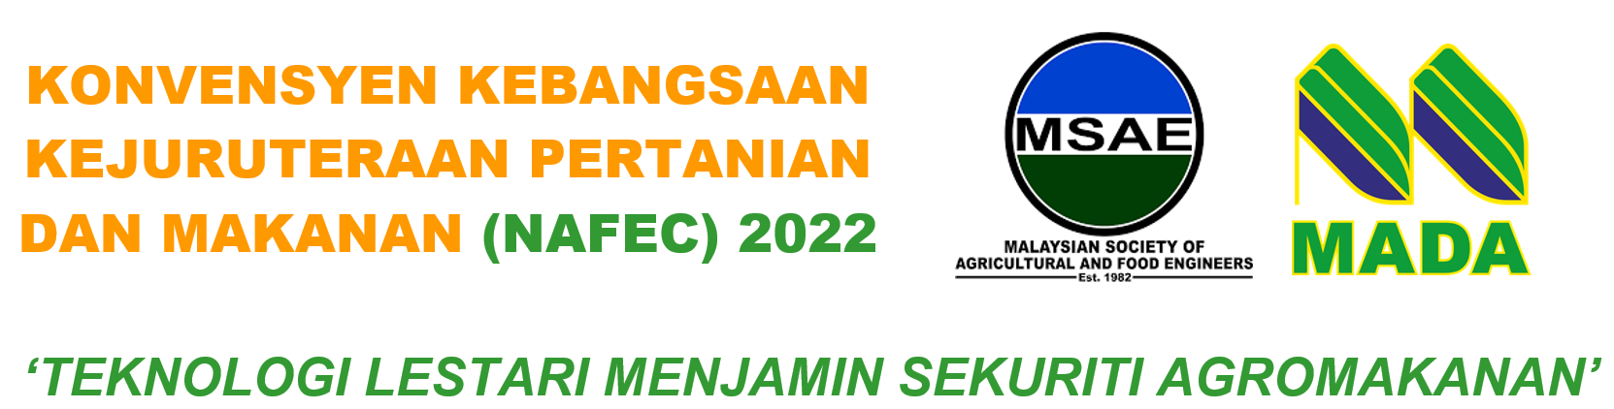

PRESENTER CONSENT FORM
Approval to the Organisers to use the presentation slides, photos and video presentations obtained during the convention.

- I hereby authorise the organiser to use, to store, to copy and to distribute the presentation slides of my paper presented for this conference.

- I also allow my pictures and videos to be recorded, stored and used for event promotions.

- By signing this, I on behalf of the co-authors

ACCEPT to publish in NAFEC 2022 Special Issue Advances in Agricultural and Food Research Journal (AAFRJ)

DECLINE for publication (note: only abstract will be published in the program book)

- I * agree / disagree* (cross out the inapplicable option) to give consent to the above matters.

Signature :

Date :

Name :

PAYMENT AGREEMENT
Name:

I/C Number/Passport Number:

By signing this agreement, I agree and accept that it is my responsibility to pay a one-time outstanding payment of RM___________ for the registration of NAFEC 2022. I further agree and accept to ensure the payment is made before 15 February 2022.

I understand that it is my responsibility to notify the treasurer of NAFEC 2022 upon payment via nafec2022@gmail.com.

I have carefully read and completely understand the content and purpose of this agreement.

I voluntarily signed this agreement by my own will.

Date | : | __________________________________
Signature | : | __________________________________
Mobile No | : | __________________________________
Email | : | __________________________________
Address | : | __________________________________

